Welcome to the Shop La Verne Digital eGift Card

*Keeping Local Dollars Local*

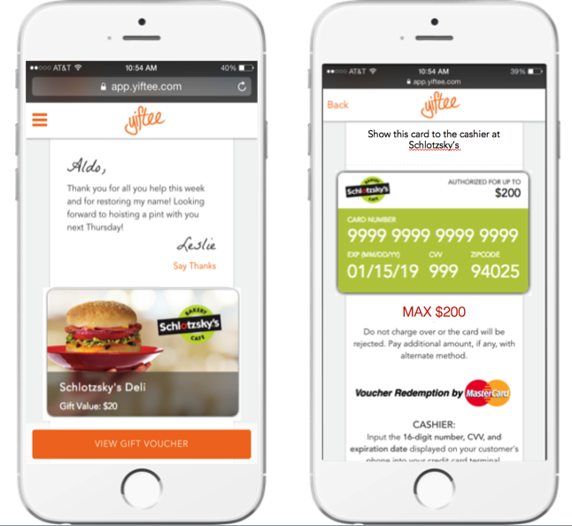

Show this card to the cashier at participating merchants in Ohio County

**The Shop La Verne eGift Card: Uniting Consumers & Local Merchants to Grow Business in Our Community**

As a La Verne business you are invited to participate in our Community eGift Card program.

Community eGift Cards are a simple way for people and companies to “give back” and drive more business into our local stores. Custom-branded for us, they are digital gift cards that can be used at any participating merchants: restaurants, salons and spas, boutiques, sports and entertainment, hotels, etc. They are a quick and easy way to keep spending local, strengthening our local businesses and building our community.

There is no special technology or administration required to participate, as long as you accept Mastercard and can key in the transaction like a phone order. **There is no fee to participate**.

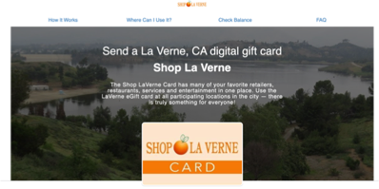

*Our community e-gift card portal*

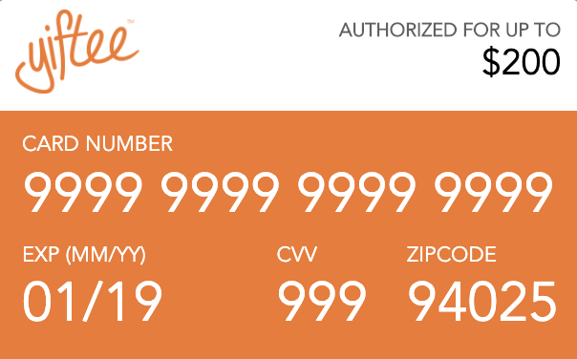

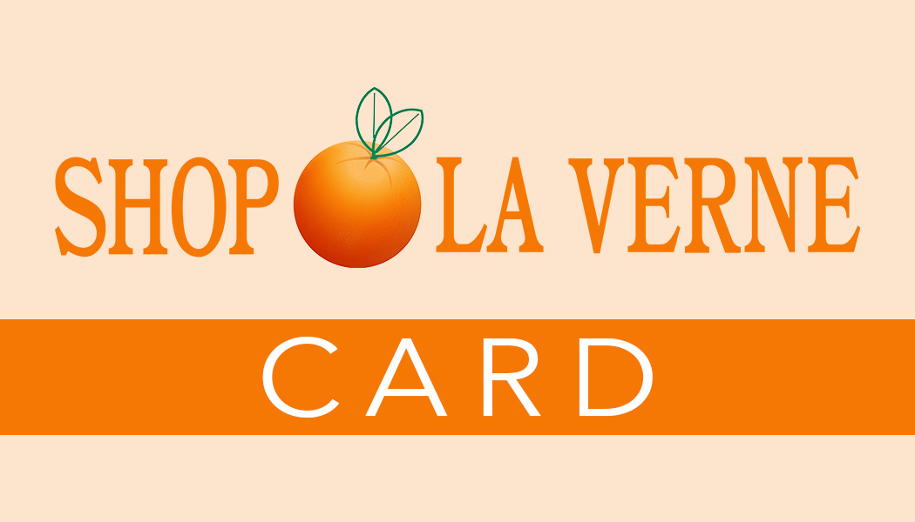

*Yiftee* *Community eGift Cards (sample images above) have kept $2M in spend local since Dec 2017. All-digital Community Cards are custom-branded and redeemed as virtual vouchers, powered by MasterCard, from mobile phones or printed. With no back-office administration, funds are automatically paid to the merchant providing the goods/services via your merchant acquirer/Mastercard.*

**How Community eGift Cards Work**

1. *Sign up with your Chamber,* office@bigbearchamber.com
2. *Run the* “*Activation Card” as a digital Mastercard on your PoS to join. Put the Community eGift Card link on your website to sell more.*
3. *People will come in your business with a Community eGift Card on their phone (or printed). Click on the* “*View Gift Voucher” bar and process it as a key-entry Mastercard credit card.*
4. *Mastercard will authorize the purchase and you are paid as usual by your Mastercard bank.*

**Who Buys Community Cards?**

People buy them online and give them as gifts, thank you’s, or just because. They can be purchased from various websites and you can sell them from your website and Facebook pages as well.

Local companies use them for employee rewards, customer appreciation, marketing and other programs. Realtors use them to thank their customers. Consumers buy them for gifts. Join now to get your fair share of this new business!

Community eGift Card FAQs

Q: Is there a deadline to participate?

*A: We are planning to launch in time for Black Friday and Small Business Saturday (11/27 & 28) to introduce the community to our new Community eGift Card. Sign up before then so that you are a part of the launch program and get this incremental business.*

Q: How do I sign up?

*A: Click this link:*  <https://app.yiftee.com/gifts/egift_and_gift_cards/hastings-on-hudson-hastings-on-hudson> *and scroll down to the “Apply to Join” button. After you sign up Yiftee will send you an Activation Card, which is a 10 cent prepaid Mastercard. Running the Activation Card is your authorization to opt-in to the program which means you agree to the Yiftee Merchant Agreement here:* <https://bit.ly/2Bqrbxm>

Q: What if I can’t process the Activation Card, which is a $0.10 credit card transaction?

*A: No problem. Process the Activation Card for your minimum amount. It will be declined but Yiftee will get the information they need to add you to the program.*

Q: What if I can’t key in a Mastercard?

*A: This is very unusual. We can introduce you to a processor who will allow you to do this.*

Q: What if the purchase is for more than the Community eGift Card value?

*A: Run the Community eGift Card for the remaining balance on the card, and ask the customer for a different form of payment to cover the rest of the transaction.*

Q: What do I do if the eGift Card is ‘declined’?

*A: The transaction is declined if you try to redeem more than the value of the card, or if any of the redemption information is mis-typed. Start the transaction over with the correct value and info.*

Q: Is tipping allowed on the Community eGift Card?

*A: No, unless you pre-authorize the amount with the tip included, since this is a prepaid card.*

Q: Does the eGift Card function as a ‘pre-paid’ credit card regarding automatic tipping hold-backs?

*A: No. It can be redeemed for the full value. But there is no tipping allowed on the Community Card.*

Q: Since the eGift Card is like a Mastercard, can it be redeemed anywhere?

*A: No. They can only be redeemed at participating locations who have run their Activation Card.*

Q: Is there a fee to purchase the eGift Card?

*A: The gift sender pays $1.00 plus 5% of the gift value. The gift recipient gets 100% of the gift value. The store is paid the full value of the card, less their normal card-not-present (CNP) Mastercard fee.*

Q: Can the eGift Card be used more than once?

*A: Yes. They are multi-use and the current balance and expiration date are always reflected on the digital voucher.  Recipients receive monthly reminders to redeem. You can check balance on Yiftee.com or* <https://c.yiftee.com/check-gift-balance>.

Q: Can I apply a refund to the eGift Card?

*A: Yes. Refunds can be applied to a valid (unexpired) card just as you would to a credit card.*

Q: Can I cancel my participation?

*A: Yes. Anytime, by notifying your organizer. You will be removed from the marketing materials online and can no longer process the cards.*